Task on Jenkins -03
1. Create one Jenkins job using the below code and create three stages.
stage1: Git clone to download the source code.
stage2: Sonarqube Integration to check the quality of code.
stage3: Slack Integration to send the alerts to slack.
Source Code: https://github.com/betawins/VProfile-1.git
- stage1: Git clone to download the source code.
Connected to the instance and installed git in it and also checked with the java version:
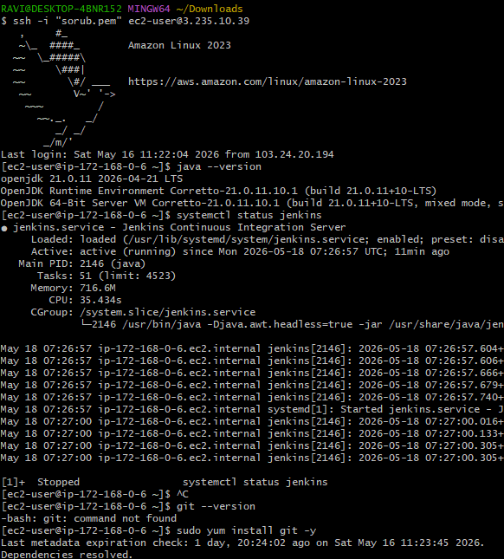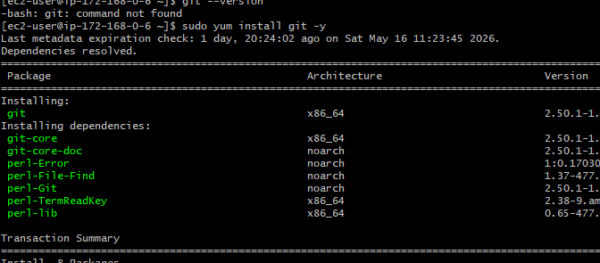
Created a new item in Jenkins with the name: git-clone-pipeline. 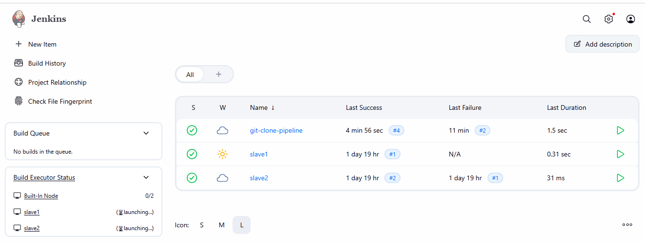
Build is being triggered with the above provided repo:
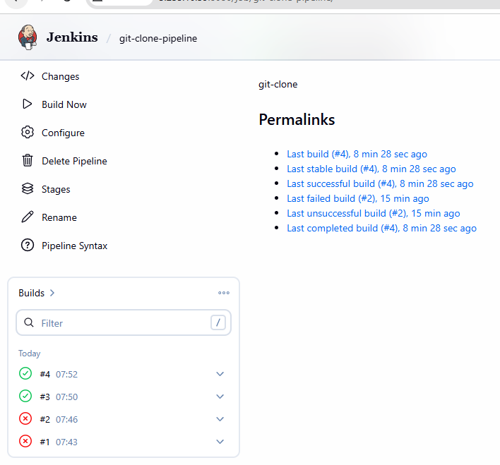
Our build is now running and successful: 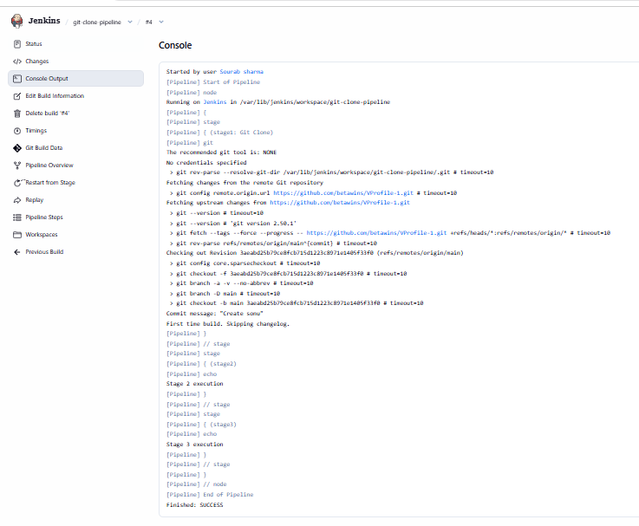
- stage2: Sonarqube Integration to check the quality of code.
Connected to the instance and then installed Java in it:
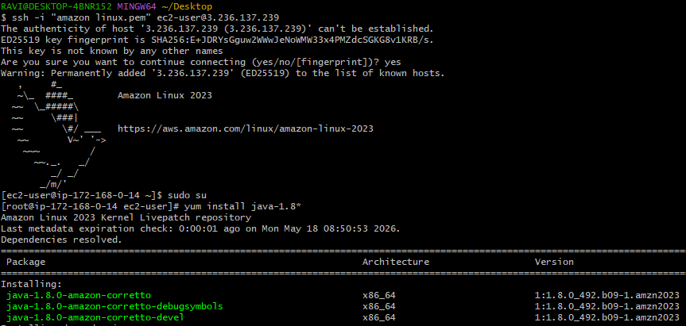
Installed the MySql:
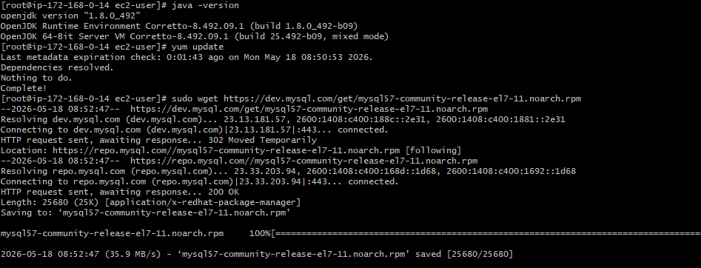 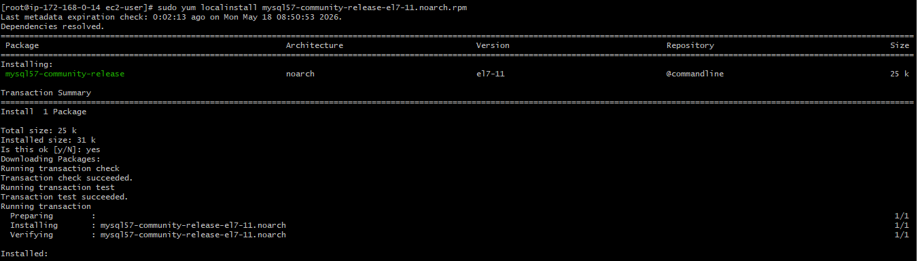 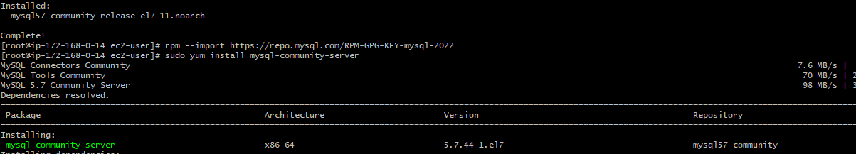
Installed the mysql in the instance and also created a new user within it as shown below:
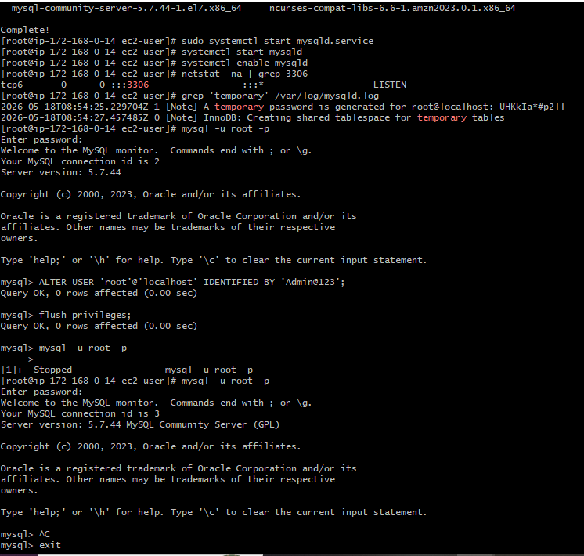
Then installed the Sonerqube in the server as shown below:
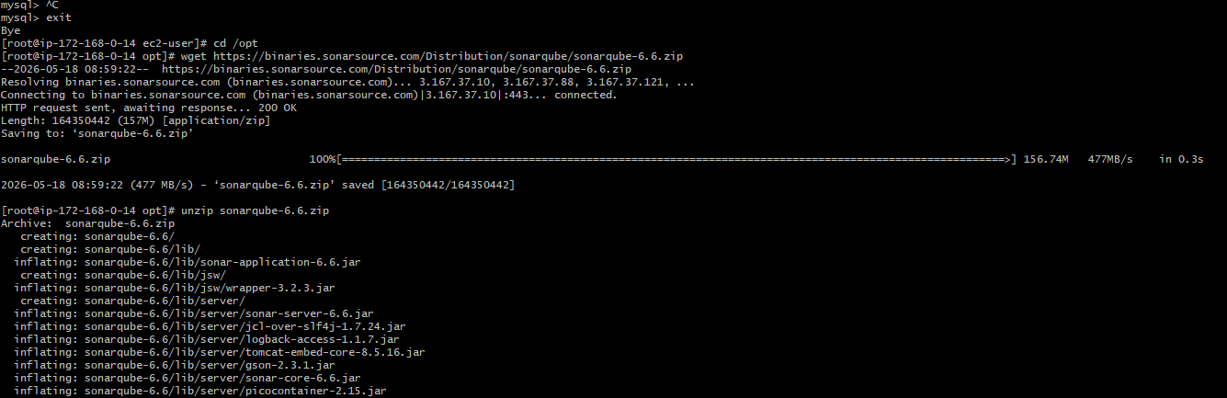
Renamed the sonar qube file:
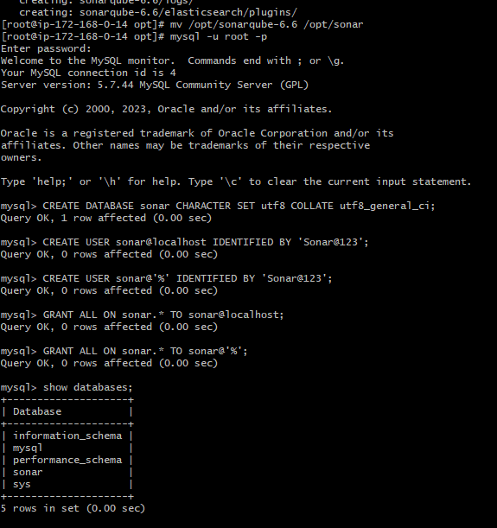
Created a new user in the root user with name{Sharma} and then added it to the sudoers list:
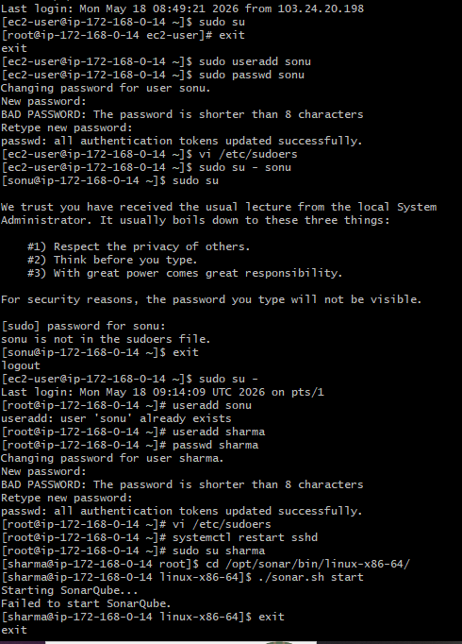
Entered in the Vi mode in the file and made the changes as shown in the document: vi /etc/sudoers
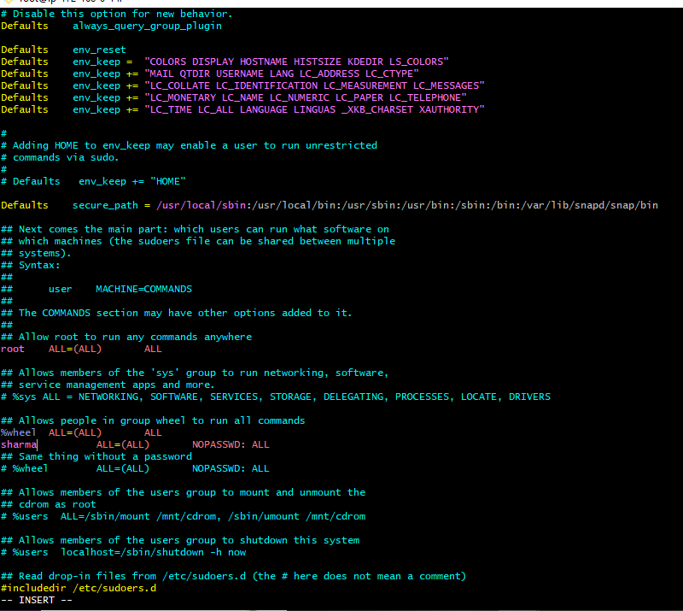
Provided the permissions to the user name and then changed the ownership and then started the sonarqube:
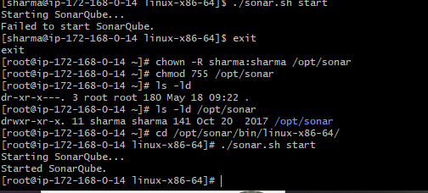
Checked with the public ip in the browser with the 9000 and then hit enter:
Then go to Jenkins > manage Jenkins > add a new plugin called as sonar scanner:
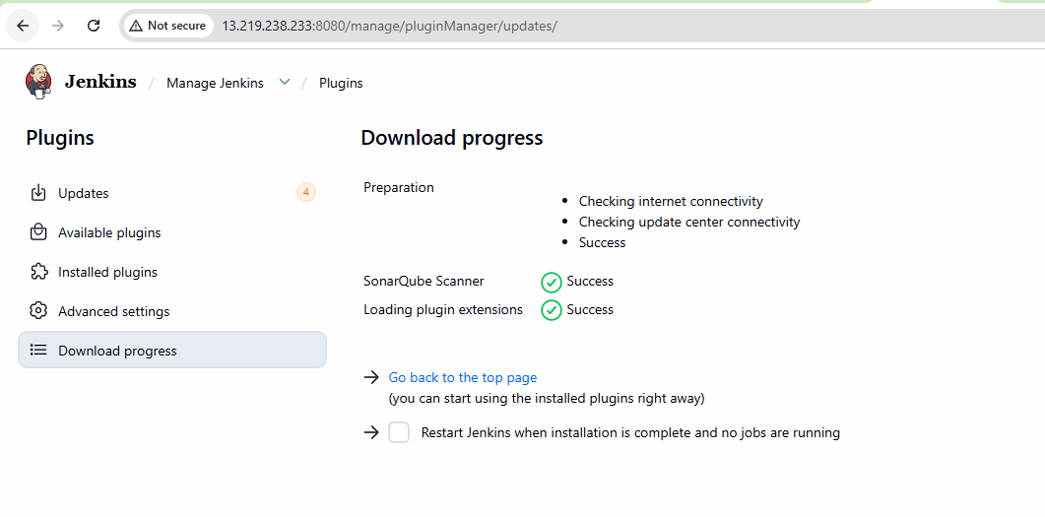
Then go to SonarQube section in manage Jenkins and then add the SonarQube with the 9000 and then hit enter: 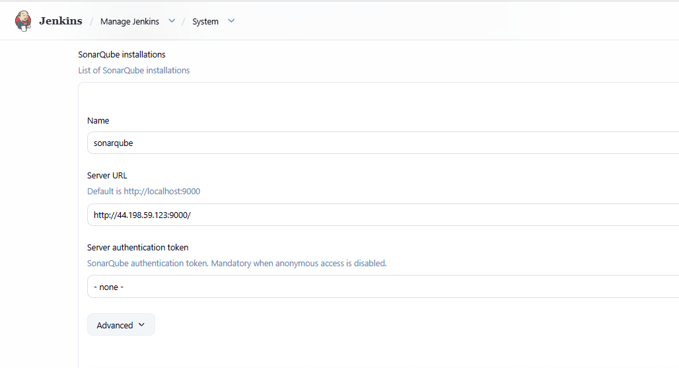
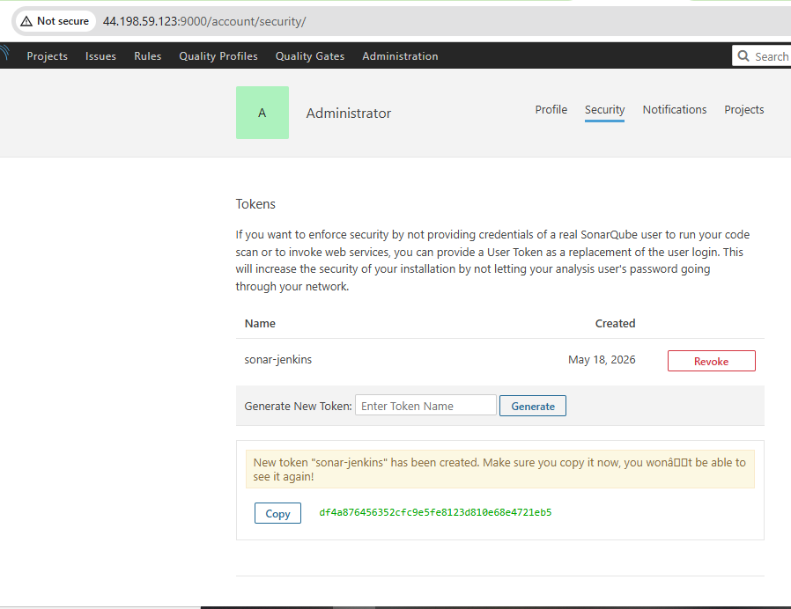
Added the security credentials in the manage Jenkins and then into credentials and then add a new one with secert key option: 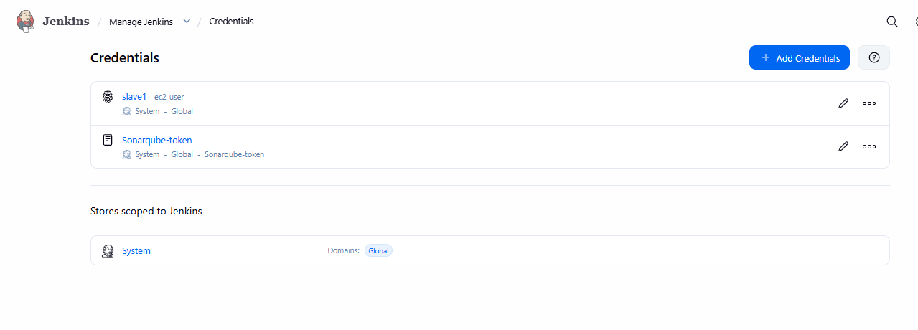
go to manage Jenkins → click on system → choose sonarqube server → add credential to server
Go to manage Jenkins and then click on system and then click on sonarqube server and then add credentials to server authentication token:
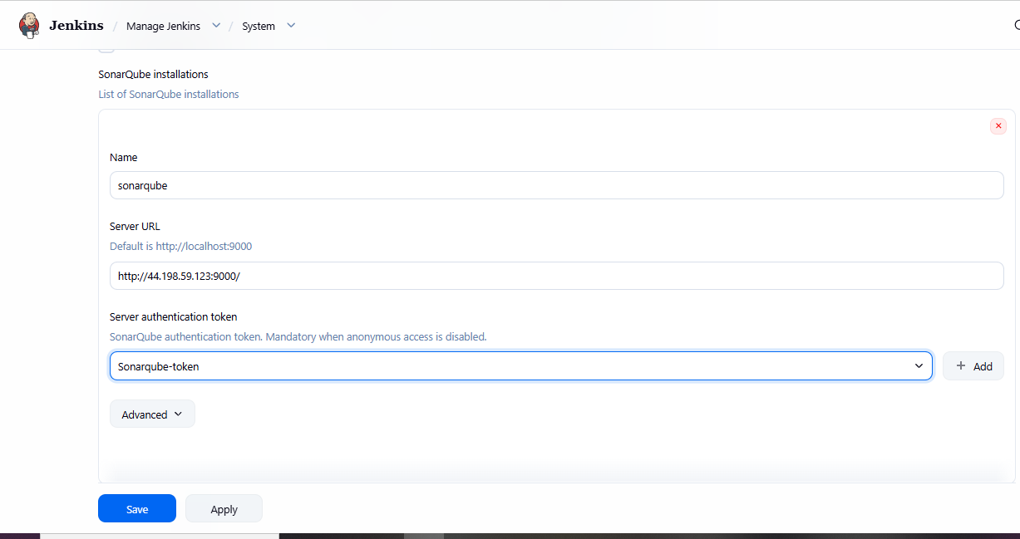
Installed Sonar scanner in the Jenkins master server as shown below:
wget https://binaries.sonarsource.com/Distribution/sonar-scanner-cli/sonar-scanner-cli-3.2.0.1227-linux.zip
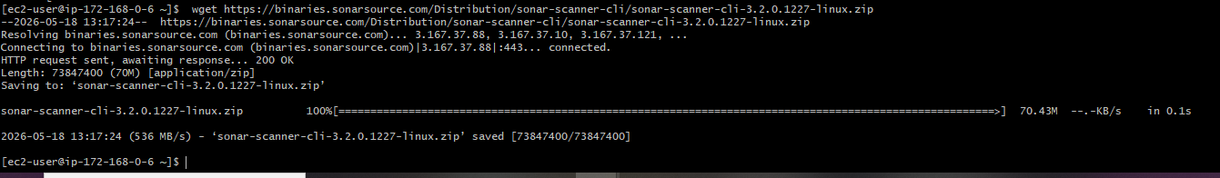
To Unzip - unzip sonar-scanner-cli-3.2.0.1227-linux.zip
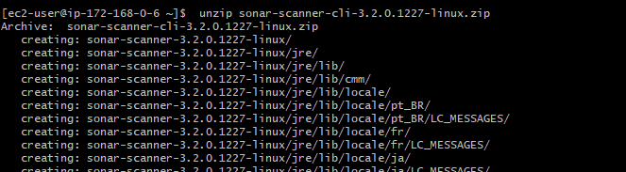
- To Rename - mv sonar-scanner-3.2.0.1227-linux /opt/sonar_scanner
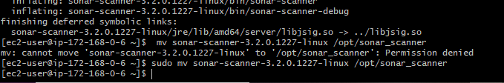
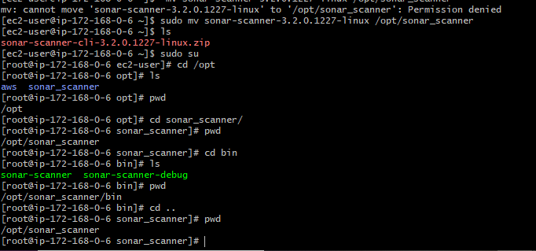
Add the above sonar-scanner path in the Jenkins
Go to manage Jenkins → sonarQube Scanner → Name → Path →Save
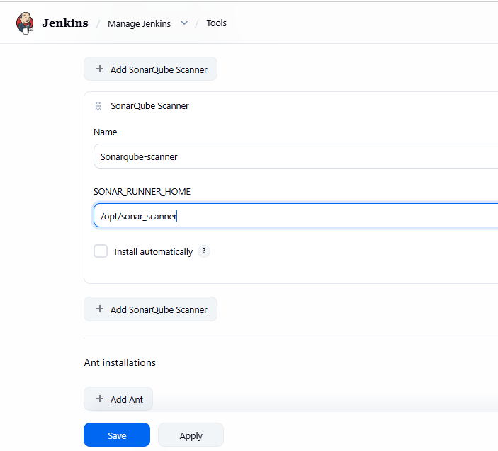
Next We need to give analysis properties of the code to run in the Job we created
Job → Configure → Build Steps → Analysis Properties(we will get it from developers)
→Save:
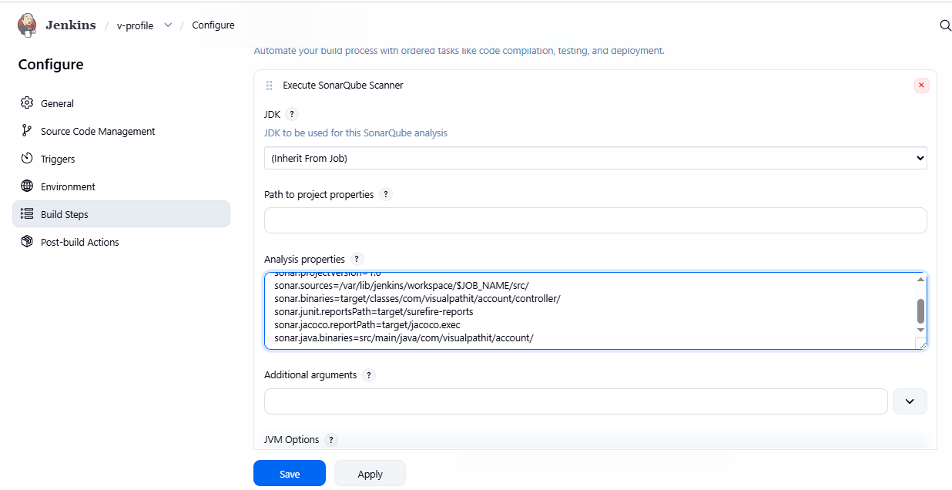
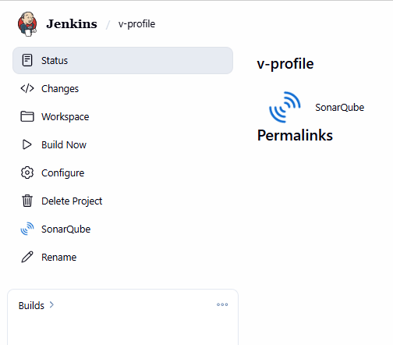
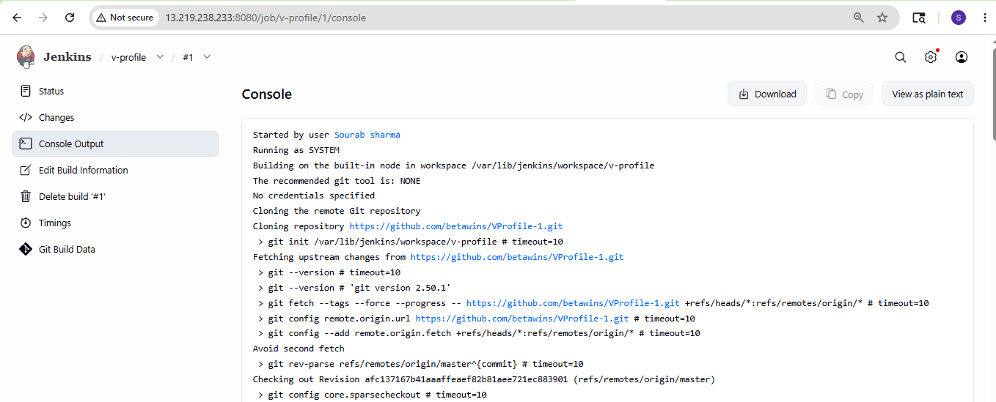
Job ran successfully:
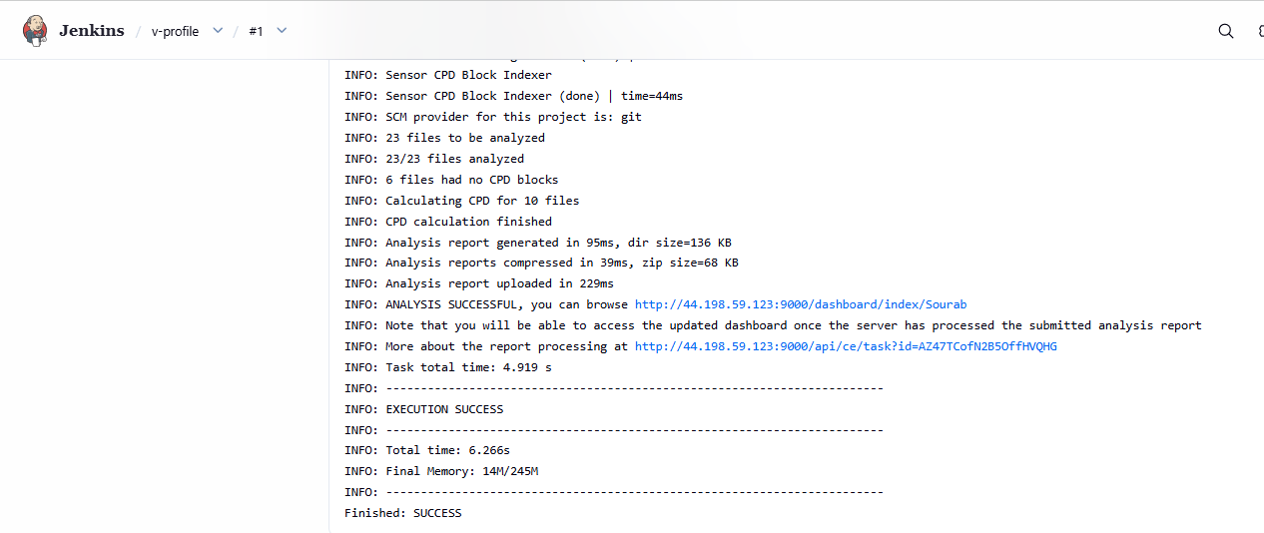
It also passed in sonarqube:
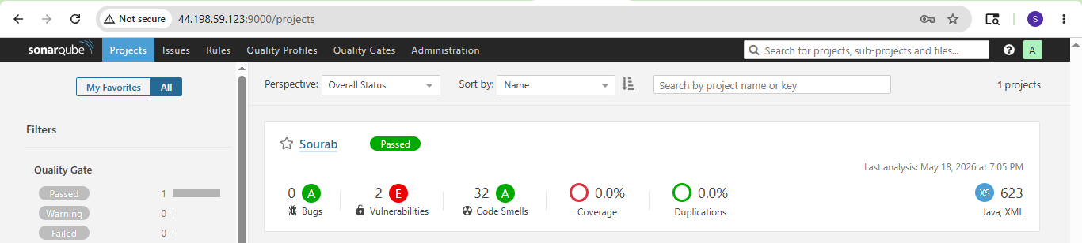
stage3: Slack Integration to send the alerts to slack.
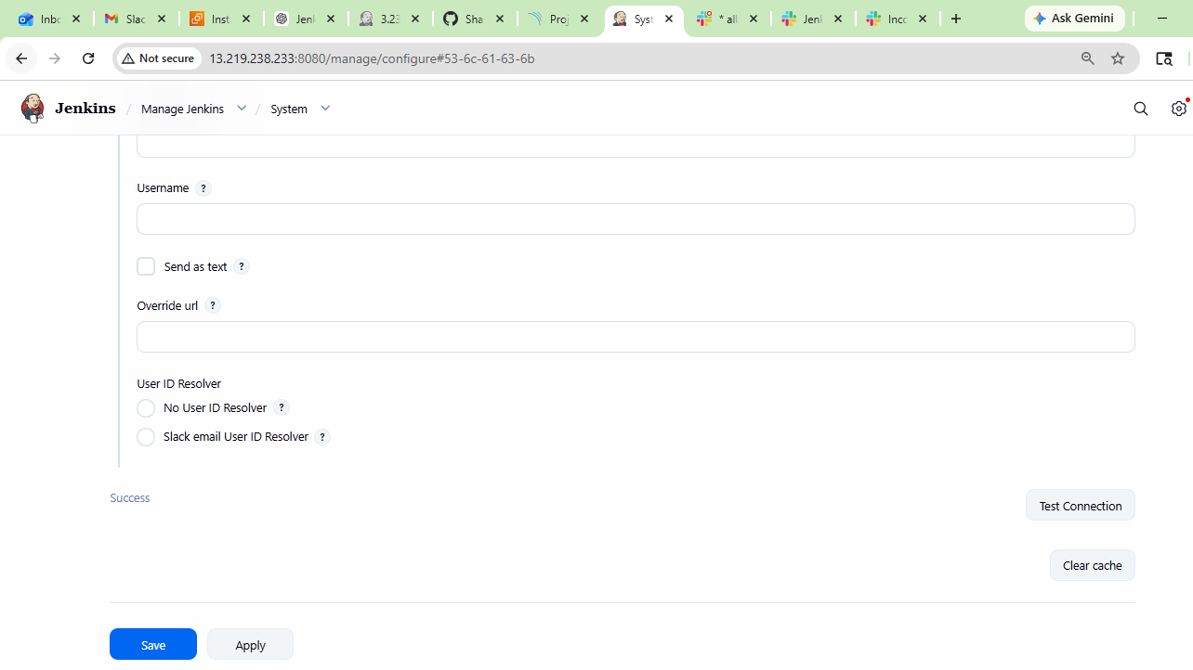
Successfully created a
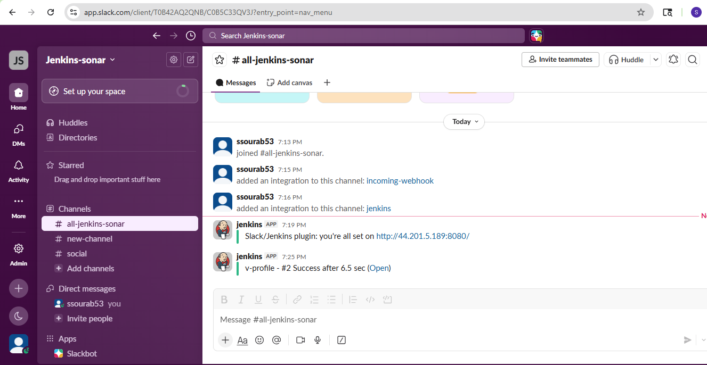
Source Code: https://github.com/betawins/VProfile-1.git
2. Create one Jenkins job using the below code and create three stages.
- stage1: Git clone to download the source code.
- stage2: Sonarqube Integration to check the quality of code.
- stage3: Slack Integration to send the alerts to slack.
Source Code: https://github.com/betawins/hiring-app.git
create a new build named hiring app
Choose git and provide url
Click on add build step >choose sonarqube scanner>Add code in analysis properties
Go to post build actions >choose slack notification>Provide workspace name >channel id >click on test connection
Click on build now
It ran successfully
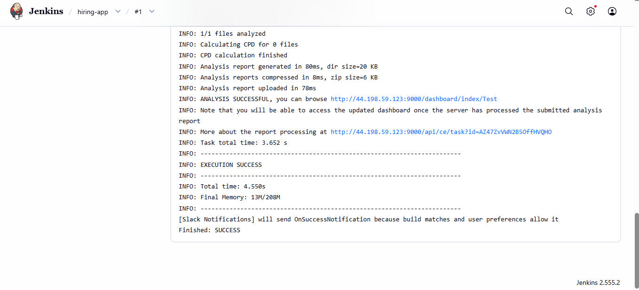
Also we can see the other project “TEST” is added in sonarqube

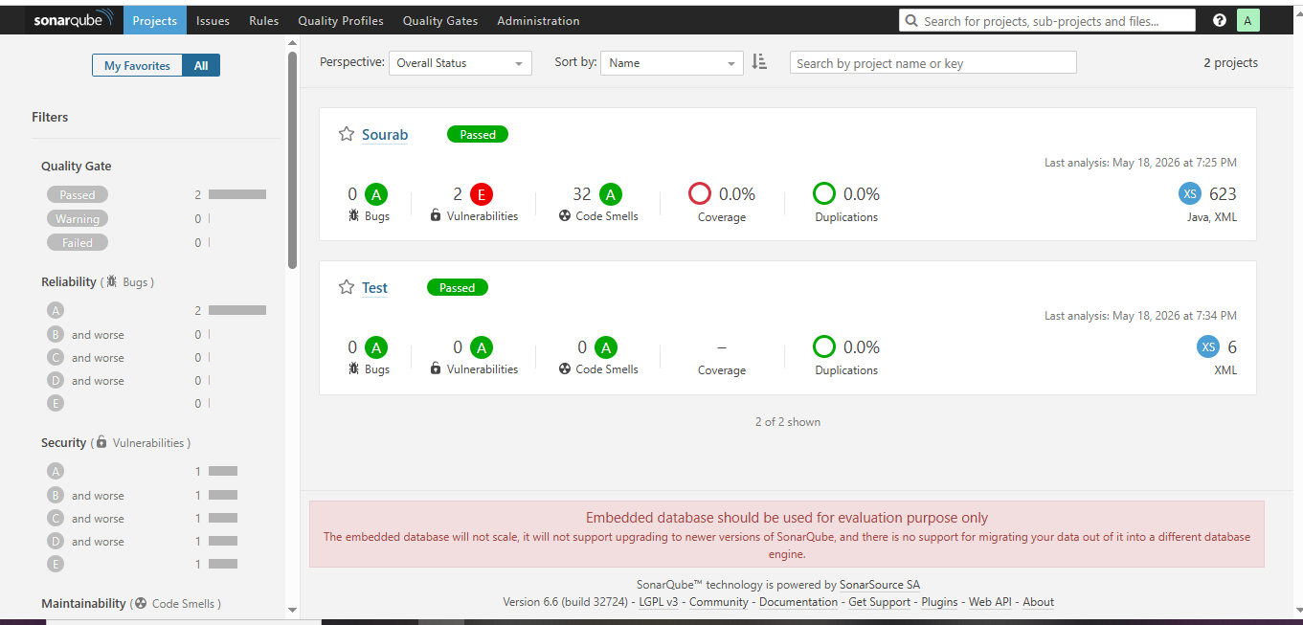
We are able to get the alerts
